Brambles Community Preschool
Healthy Eating For Your Preschooler
Fuel your child’s body head to toe.
What you need to know:
Eating well is important. Children need to eat well in order to grow and develop and be active and healthy. A healthy, fun and enjoyable lunch gives a child the energy they need to play and learn within preschool.
Use the information provided to help make a healthier lunch for your child. Please support Brambles healthy eating policy by following these guidelines.
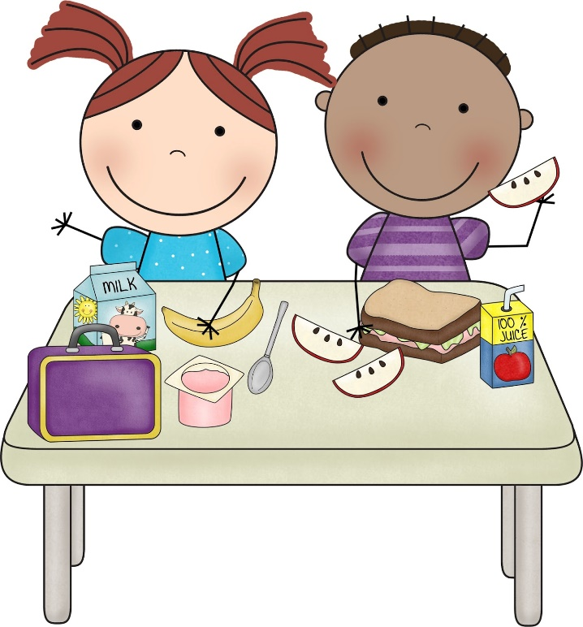
What is a healthy packed lunch?
A healthy packed lunch is a balanced meal providing a variety of nutrients for your childs growth and development. Please read the list of food and snacks for ideas.
Starchy Foods – Pasta, Couscous, Rice, Wraps, Pitta bread or Sandwiches – why not try different types of bread such as wholegrain, fruit or seeded breads? Also you can make sandwiches more fun by cutting them into fun shapes with cookie cutters!
Meats and Alternatives – Lean meats such as chicken, turkey or ham.
Fish such as Tuna, Mackerel, or Salmon.
Hard boiled eggs or mini quiches.
Meat alternatives such as quorn, soya or tofu.
Milk and Dairy Foods – Yoghurts, Cheeses such as cottage cheese, edam, soft cheeses or cheese cubes.
Fresh Fruit and Vegetables – Any fresh, frozen, tinned or dried fruit or vegetable. It is important to add fruit and vegetables to your child’s packed lunch as they are packed with vitamins, minerals and fibre that is necessary for the body to function properly and to keep strong and healthy. Why not make vegetables more fun and provide a dip like Hummus?
Drinks – Brambles provide both Milk and Water during lunch and snack time so no need to provide a drink in your child’s lunch box.
Healthy packed lunches don’t have to be boring, be creative and have fun. Let your child help prepare their own lunch, they are more likely to enjoy food they have made themselves. Try to vary the contents of the lunchbox each day to keep things interesting and fun for your child.


